**XYZ Bank - Documentation**

The XYZ Bank application it's an application created for the usability both of the costumers and the bank manager. With this app the customer should be able to check his bank account and see the transactions he has made over one period, the credit balance and he can deposit or withdrawl money to and from his bank accunt.

* When entering the application it should display a screen with the possibility to select Bank Manager Login or Customer Login.

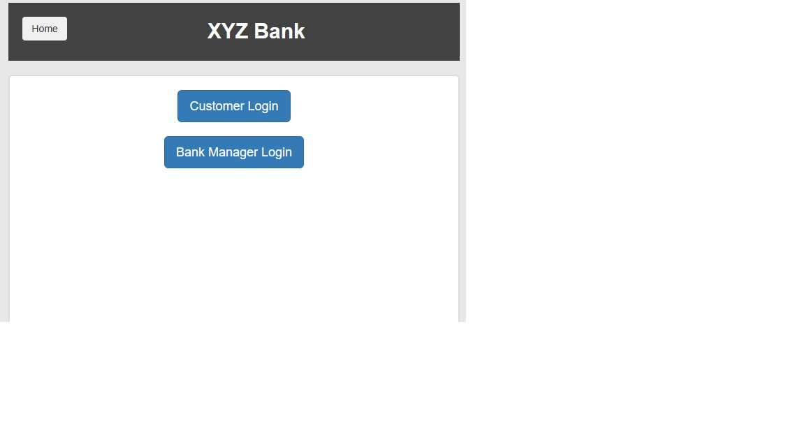When the user selects Bank Manager Login the app will open and it can have the following buttons:

1. Add Customer – when pressing the add customer button, the app will open the fields to can create a new customer. The modal will contain:

* First name field: the customer should enter his real first name, that will be formed only with letters, no string. The field it’s a required field, so a new customer can’t be created without complete the field.
* Last name: the customer should enter his real last name, that will be formed only with letters, no string. The field it’s a required field, so a new customer can’t be created without complete the field.
* Post code: the customer should enter his post code, that will be formed only by numeric characters. The field it’s a required field, so a new customer can’t be created without complete the field.
* SSN (Social Security Number) - the customer should enter his real SSN, that will be formed by numeric characters. The field it’s a required field, so a new customer can’t be created without complete the field.
* Email address: the customer should enter his valid email address. When the add customer button it’s pressed, an automatically email will be send to the new customer, that will be needed when he will open a new account.
* Add Customer button – should be white and when hover should be grey. After all the fields valid and completed and the user press add customer button, the message will be displayed: Customer added successfully with customer id:(the customer ‘s number).
* If you try to create a new customer without complete all the fields, then a message will be displayed: “Please fill out this field”.

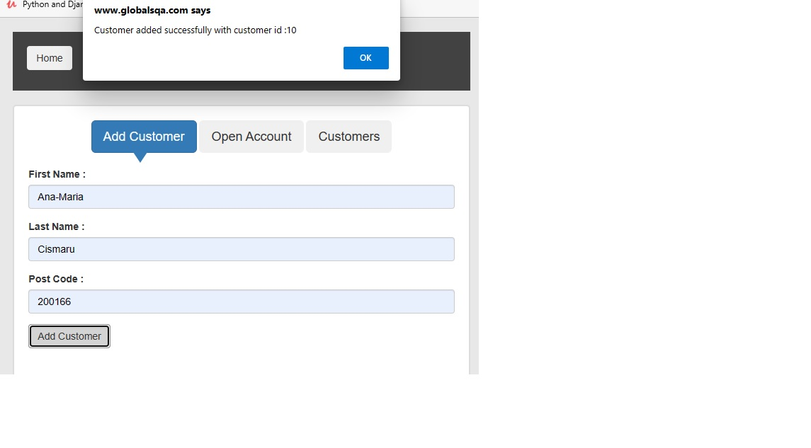2. Open Account section:

When pressing the open account section, the following fields will appear into the modal:

* Customer – you should choose the new customer’s name that you have created previously. You can either type or select it from the drop down.
* Currency: - you should be able to choose from the drop down the actual currency that you want your account to have. You can choose it from the drop down list with all the currency existing at this time.
* Personal Numeric Code – enter the personal numeric code that was automatically sent to your email address when you have created a new customer. It is a numeric code formed by 7 numbers.
* Process button – press the process button to can successfully open an account. The message should be desplay: “Account created successfully with account Number: “

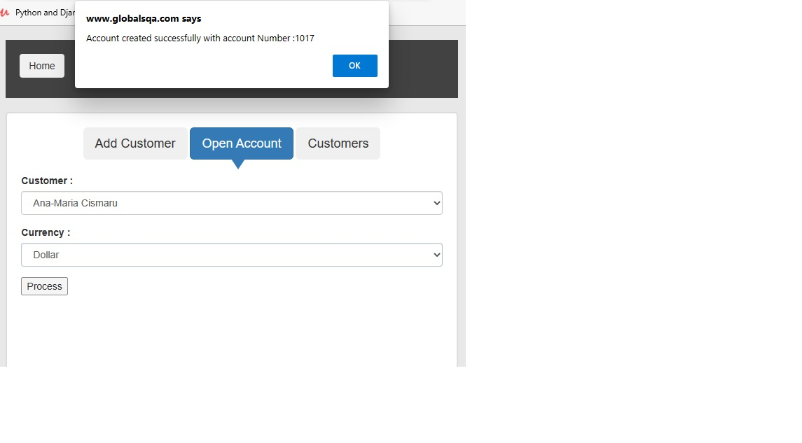3. Customers section

When pressing the customer section it should be a list with all the customers that have been created and the list should contain the details of the customer and the possibility to delete the customer from the bank fields.

* Customer ID – it should be the id that was generated when the customer was created. It is a numeric code and the bank manager should not have the possibility to change or modify it.
* First Name – it should be the first name that was completed when created the customer. The manager should be able to organized the section by alphabet, from A to Z.
* Last Name – it should be the last name that was completed when created the customer. The manager should be able to organized the section by alphabet, from A to Z.
* SSN – It should be the social security number entered when a new customer was created.
* Account number – it should be the account number that was created when the customer opens an account.
* Currency – it should be displayed the currency selected when a new account was opened.
* Delete customer – when the bank manager want s to delete a customer, he can be able to do that only by pressing the delete button.

